Do Frequency-Tagged Steady State Potentials Reflect Timing-Related Behaviours?

Kyle Ing
University of Western Ontario
NEURO 4000
Dr. Jessica Grahn, Dr. Karli Nave
Apr. 8, 2024
Abstract
The ability to perceive musical beat is integral to the music listening experience. Our understanding of the mechanisms responsible for beat perception have evolved in the past decades. The discovery of beat related steady state-evoked potentials (SSEPs) led to the use of frequency-tagging as a common electroencephalography technique, as their presence and amplitudes have often been used to reflect entrainment of the beat of music. However, recent inconclusive findings regarding their relation to beat related behaviours have put this into question. In addition, while there is literature that examines the individual factors that are related to behavioural measures of neural entrainment of beat, the same cannot be said about individual differences in relation to SSEP amplitudes. This study aims to investigate the relation between beat related behaviours and the SSEPs that proposedly represent beat perception, as well as to determine any other exploratory factors related to SSEP amplitude. While having electroencephalogram activity recorded, participants completed a sustained beat task, designed to induce and test for natural beat perception. Our multiple linear regression revealed no significant predictors for beat frequency-tagged SSEPs, but more importantly a need to refine the model and account for failed assumptions. A simple linear regression did show a significant predictor in beat related task behaviour, warranting further investigation.
1 Introduction
For its ability to indiscriminately span across time and cultures, music is widely considered as a universal language. The goal to understand our experience with music has led researchers to break down its elements and the corresponding mechanisms for their perception. One such fundamental element is beat, defined as the underlying periodic pulse in which rhythmic structure exists within. Beat perception is often exhibited naturally when listening to music as spontaneously synchronized movements, such as head nodding or foot tapping (Jackendoff & Lerdahl, 2006). The underlying mechanisms of such a nearly ubiquitous mental event have become a subject of intrigue in the world of music cognitive research. Beat perception is believed to have a multitude of exogenous factors regarding the physical properties of sound stimuli such as melodic contour and articulations that give rise to subjective experiences (Hannon et al., 2004; Drake, Penel, & Bigand, 2000). In addition, endogenous processes that do not rely on said physical properties can also affect the perception of beat (Abecasis et al., 2005). One prevailing theory is that of neural resonance, in which intrinsic oscillations in neuronal firing entrain to external rhythmic stimuli (Large & Kolen, 1994). According to this theory, beat perception is a product of neural populations resonating to the stimulus frequency, giving rise to higher order harmonics that correspond to beat.
1.1 Background
Neurophysiological evidence for this neural resonance was established when Nozaradan et al. (2011) used an electroencephalogram (EEG) to capture steady state evoked potentials (SSEPs) that reflected the stimulus frequency as well as the harmonics corresponding to the frequency of an imagined beat. Tagging the frequencies at which the stimuli and beat periodicities occur has since become a common practice to examine the spectral power of the electrophysiological responses that are thought to reflect the endogenous neural entrainment proposed to underlie beat perception.
There is evidence that SSEPs at these tagged frequencies can reflect behaviour. When examined in relation to performance in some temporal tasks, the strength of neural entrainment at the stimulus frequency (what we define as the frequency of each regular event , note that some studies in the literature use different terminology) is predictive of temporal prediction abilities (Nozaradan et al., 2016). These findings make up a large part of research into beat perception, with similar conclusions being suggested in other studies that investigate the nature of beat-related neural activity, as well as studies relating beat-related SSEPs to various behaviours such as rhythmic body movements (Chemin et al., 2014, Tal et al., 2017). At the present time, only indirect evidence exists for a relation between frequency-tagged SSEPs and behaviours, especially at the beat level.
1.1.2 Background Limitations
As with all studies, the two key findings from Nozaradan et al. (2011, 2016) were not derived without limitations that may have implications for the interpretation of results. Firstly, the task employed by Nozaradan et al. (2011) requires metric imagery, the willful generation of an imagined beat on top of stimuli that are ambiguous to beat. As beat perception is often a naturally occurring event that requires no willful effort, it is possible that the beat-level SSEPs observed with imagined beat are specific to other cognitive processes that mediate attentive perception of beat. The disadvantage of using natural musical stimuli is that it can be hard to determine if the neural activity in question reflects exogenous processes that respond to properties in the stimuli, or endogenous processes that hold a metric framework for the onset of beat events. To control for this, Nozaradan et al. (2016) varied the level of syncopation in rhythmic stimuli to induce degrees of entrainment, reasoning that syncopated rhythms rely on more endogenous processes. Descriptions of syncopation support this as it is described as a natural element of various musical styles such as jazz and funk, in which emphasis of rhythm is shifted from strong to weak beats, which can violate metric expectations (Longuet-Higgins & Lee, 1984). This allowed for the quantification of entrainment, used to compare with behavioural measures such as synchronization. However, the proposed issue lies with the possibility of confounds stemming from the nature of the stimuli. The correlation between entrainment and asynchrony was found to have an influence of syncopation primarily at slow tempi, in which syncopation resulted in relatively earlier taps. As a result, greater entrainment looked to result in less asynchrony. This however may be due to beats in syncopated rhythms being more easily predictable, introducing anticipation as a possible influence on the behavioural results. The larger factor of relevance though, which is not a limitation per say, is that the aforementioned study is focused on general timing abilities at the stimulus frequency rather than what we’ve defined as the beat in the current paper.
To circumvent the limitations and factors mentioned, Nave et al. (2022) induced endogenous entrainment of the beat without the use of syncopation. They employed a task design in which perception of beat is induced by context stimuli, which is then maintained over a metrically ambiguous stimulus. In addition, the beat induction used real excerpts of music chosen to induce either binary (3/4) or ternary (6/8) beat in a naturally occuring fashion, without the requirement of imagining beat. SSEPs were found at the expected stimuli frequency and beat frequencies (the frequency of down beats in a meter, or regular groupings of events at the stimulus frequency), however the relation to behavioural performance was not as conclusive. The task used resulted in trials that were either correct or incorrect, and the SSEPs tagged at the beat frequency only correlated with task accuracy for correct trials. In a similar vein, a provisionally accepted pre-registered replication and extension of Nozaradan et al. (2011) done by Nave et al. (2023) found that task performance was correlated to SSEP amplitude at the stimulus frequency, but was unrelated to the beat-level SSEPs. Additionally, though beat-level SSEPs were replicated, the effect sizes were much smaller. For frequency-tagged SSEPs to be fully compatible with resonance theory, the harmonics that coincide with beat frequency should reliably predict behavioural performance. These results highlight an existing gap in knowledge regarding the mechanisms behind perception of metric stimuli.
1.2 Exploratory Factors
Previous literature offers insight into factors proposedly related to neural entrainment. Temporal production ability, which can be measured by a synchronization-continuation task, is one such factor. McPherson et al (2018) found that synchronization-continuation task performance correlated with performance on spontaneous motor tempo task performance, a task reflecting endogenous rhythmicity. The findings drawn from Nozaradan et al. (2016) also provide factors of interest, as temporal prediction measured by a tempo perturbation task, were found to predict SSEP amplitudes. With the finding by Nave et al. (2023) that only the stimulus frequency correlated to behavioural measures, it is very possible that the SSEPs of interest are more related to general temporal abilities.
Music expertise is another proposed factor. Literature exploring associations between synchronization ability and development have suggested that musical training across one’s lifespan contributes to auditory-motor integration (Thompson et al., 2015). Studying the factors that are associated with individual differences in beat perception is important to understanding the conditions that birth this ability. Pertaining to SSEPs, the factors that possibly affect their presence could have implications on the nature of neural resonance and behaviour. Trait empathy is a more exploratory factor, as evidence has linked it to performance on rhythmic entrainment tasks (Bamford & Davidson, 2019).
The simulation theory of empathy suggests that motor activity is stimulated when observing another’s behaviour (Ravenscroft, 1998). It is possible that the simulation theory could be applied to music, as the production of music is a specific human activity, and often encourages movement. Maintaining a beat can then be thought of maintaining the intended movements of the music producer.
1.3 Research Goal and Purpose
The overarching goal of our study is to investigate the nature of frequency-tagged SSEPs at the beat and stimulus frequencies. This can be formalized into two research goals. The first and our main goal is to investigate how frequency-tagged SSEP representations relate to beat related behaviours. To examine the relation between tagged SSEPs and beat related behaviour, we employed a paradigm similar to the one used by Nave et al. (2022) to invoke endogenous natural beat perception, while capturing SSEPs using EGG. If beat-level SSEPs are found to relate to beat related behaviours, then our results would support the notion that beat-level SSEPs are indicative of beat entrainment. If the results point to the contrary, then this study will be added to the recent body of literature that suggests that beat-level SSEPs at the very least have an inconclusive relationship to beat entrainment. Our second research goal is to explore other possible factors that may be related to SSEP amplitudes, including general temporal abilities, musical sophistication, and trait empathy. If general temporal abilities are found to be predictive of beat-level SSEPs, it may suggest that more general mechanisms related to beat perception but not necessarily perception itself may be closer related to SSEP activity. If our exploratory factors of musical sophistication and empathy show any relation, it could support the notion that these factors are related to beat or timing abilities, warranting future investigations into such relationships.
2 Materials and Methods
2.1 Participants
Ten participants (7 female) were recruited, with the majority being students found through the SONA participant pool at The University of Western Ontario (M_{age} = 21.5 years, SD = 3.98, Range: 18– 32 years). No participants had any underlying neurological differences such as ADHD, and no participants were excluded for reasons such as noisy EEG data. Those recruited through SONA were compensated with credit, and those recruited elsewhere received $10/h.
2.2 Task Overview and Procedure
Participants completed 4 different tasks on a computer, in which tapping was registered through the ‘M’ key. The first is our main task called the sustained beat task, which consists of 2 blocks of 32 trials designed to invoke natural perception and probe related behaviour through the measure of asynchrony. Prior to the experimental trials, two example trials and four repeatable practice trials were given to ensure that the participant understood the concept of beat and when they were to tap. The example stimuli would be similar to the testing stimuli, but with a drum hit to indicate when to tap. The set of practice trials included example stimuli that covered each of the condition combinations of tempo and beat context. A headphone splitter was used so that the researcher could listen in on the practice and ensure the participant understood the task if necessary. Participants were instructed to listen to the auditory stimuli and tap to the beat when given the visual cue. This would repeat for all 32 trials in both blocks, with an optional break in the middle of each block.
The next task is the tap-to-music task designed to assess beat perceptual abilities, followed by the tempo perturbation task and synchronization-continuation task, both designed to assess general timing related abilities.
In addition to these behavioural tests, a series of questionnaires and indexes were given to assess demographic data, trait empathy, interpersonal reactivity measures, and musical sophistication.
2.2.1 Sustained Beat Task Experimental Design
Our paradigm was designed to induce beat perception in participants and have them maintain it over a duration of time. The task is made up of two blocks being music and metronome blocks, each with 32 trials each. Each trial consisted of three phases, the first of which being the beat induction phase. Both blocks have nearly identical stimuli, with the only difference coming in the first phase. In this phase, beat is induced through the presentation of an auditory context stimulus. For the music block, each stimulus is an excerpt of real music, as compared to isochronous tones in the metronome block. In both cases, the stimuli is designed to induce either a binary (3/4) or ternary (6/8) context through musical properties. The beat induction phase is followed by the beat maintenance phase. For both blocks, isochronous tones are played with the absence of any properties to suggest the presence of a beat, making it ambiguous as to whether it is binary or ternary when listened to in isolation. Participants must maintain the beat percept they obtained from the context stimuli in the beat induction phase. A probe phase followed in which there is no change in the ambiguous stimuli but participants are asked to tap to the beat. If the beat percept is maintained throughout the beat maintenance phase, then theoretically participants should be tapping to the same beat context which was induced by the context stimuli. See Figure 1 for a visual representation of the paradigm.
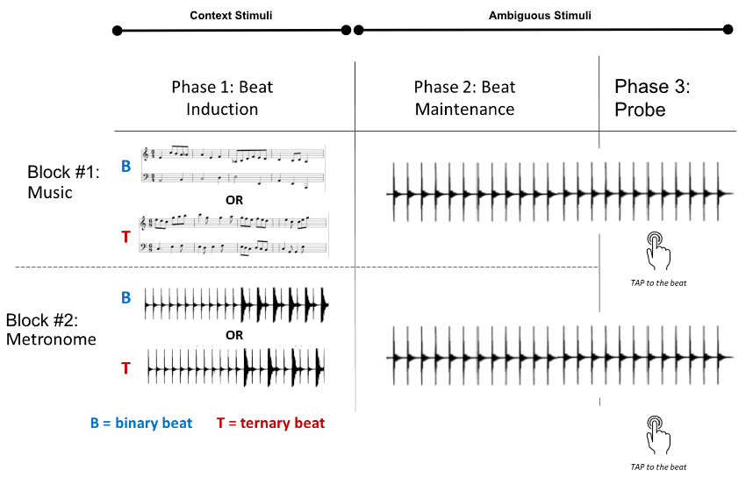
Figure 1. The paradigm for one individual trial in the sustained beat task. Changes in the stimuli in context to phases are shown at the top. The upper and lower blocks visually detail the differences in Phase 1, while the stimuli are shown to be the same in the next two phases.
2.2.2 Tap-To-Music Task Design
The Tap-to-Music task is modeled after a section of the Beat Alignment Test (BAT) developed by Iverson and Patel (2008). Participants are presented with a musical excerpt and are instructed to immediately tap to the beat until the end of the excerpt. Whereas the BAT uses its own set of musical excerpts from differing styles, the Tap-to-Music Task uses the context excerpts from Phase 1 of the first block of the Sustained Beat Task.

2.2.3 Tempo Perturbation Task Design
The Tempo Perturbation Task is similar to the task established by Pecenka, Nadine & Keller (2013) in their measure of temporal synchronization. Consisting of five trials, participants are presented with a series of tones that increase and decrease in tempo. Participants are asked to synchronize their tapping with the tones.
2.2.4 Synchronization-Continuation Task Design
The Synchronization-Continuation Task has been used in a multitude of studies (McPherson et al., 2018; Repp & Steinman, 2010; Styns et al., 2007). Our task consists of 3 trials in which a series of isochronous tones would play and gradually fade out. The participant is instructed to synchronize their taps to the tones and continue tapping at the same interval after the tones fade out.
2.3 Stimuli Descriptions and Creation
2.3.1 Sustained Beat Task Stimuli
The stimuli for the sustained beat task were modified from a previous study done by Nave et al. (2022) in which MIDI files were sequenced as the Steinway Grand Piano in Logic Pro X (Apple, Inc., 2015). In the music block, the beat-inducing stimuli came in the form of musical excerpts that used melodic and rhythmic cues to suggest a binary or ternary context. The binary context is described as having eighth notes alternating between being a strong or weak event, such that the first, third, and fifth beats are strong beats (SW-SW-SW). The ternary context has strong events at every third note (SWW-SWW). Our context stimuli uses compositional techniques such as specific melodic contours and rhythmic structures to emphasize the prominent metric events and evoke the sense of ternary or binary context, as seen in a long history of western counterpoint, in line with established theories (Povel & Essens, 1985). The metronome block uses metronomic stimuli in which the same piano notes are repeated as isochronous rhythmic events. The tone for every six notes would alternate between middle C (261.63Hz) and the E (329.63Hz) above it. The changing tones act as an anchor to prevent phase-shifting of the beat percept. Binary and ternary contexts were suggested through the presence of accents at every two or three notes respectively, in which accented notes were given more salience by increasing the note by 6.0dB. In both cases, there was an equal amount of binary and ternary stimuli. Both sets of stimuli had trials that differed not only by the beat context, but also by tempo. At the slow tempo, the basic stimulus level isochronous events had an inter-onset interval (IOI) of 300ms. Binary events would occur at every two events while ternary events would occur at every three, leading to an inter-beat interval (IBI) of 600ms and 900ms respectively at the slow tempo. The fast tempo had stimuli level events with IOIs of 200ms, coinciding with binary and ternary IBIs of 400ms and 600ms respectively. The two tempos were chosen such that the frequency of the ternary events at a slow tempo would equate that of the binary context at a fast tempo, controlling for any possible differences that may result from the differing frequencies of the beat at any given tempo. In the music block, there were 8 different musical excerpts played twice at the two tempos, totalling 32 trials. The metronome block only had 4 different patterns but were repeated to equal the amount of trials in the music block. For each trial, the beat induction phase lasted 8 bars, the beat maintenance phase lasted 16 bars, and participants would have to tap for the remaining 8 bars during the probe phase.
From the start of each trial to a bar prior to the probe phase, participants received a visual instruction to listen. During the last bar of the beat maintenance phase, participants are given a cue to prepare to tap. During the probe phase participants were given a visual cue to tap until the end of the trial.
2.3.2 Tap-to-Music Task Stimuli
The stimuli for the Tap-to-Music task consists of the 40 excerpts from the first phase of each trial in the first block of the Sustained Beat Task (32 excerpts from the experimental trials and 8 from the pool of possible excerpts used in the practice trials). These were created for a study done by Nave et al. (2022) in which MIDI files were sequenced as the Steinway Grand Piano in Logic Pro X (Apple, Inc., 2015).
2.3.3 Tempo Perturbation Stimuli
The stimuli for the Tempo Perturbation Task were created using native plugins and functions within Reaper (Cockos, Inc., 2022). The set of five trials uses many of the same parameters found in Pecenka, Nadine & Keller (2013). Each trial begins with five to eight isochronous pacing tones at 987.77Hz (B5 in equal temperament) with IOIs of 600ms. The tones then go through a series of six tempo increases and decreases, alternating between reaching IOIs of 387ms and back to IOIs of 600ms. Each tempo change can occur over either five, eight, or ten tones, and each trial includes an increase and decrease with each of those sizes. The last tone of each tempo change segment is shared as the first note of the next segment, except for the very final slow down which also includes an extra tone to establish a final IOI of 600ms. The end of the trial is marked by a stop tone of 783.99Hz 1200ms after the final tone.
2.3.4 Synchronization-Continuation Stimuli
The stimuli for the Synchronization-Continuation Task were created using native plugins within Reaper (Cockos, Inc., 2022). Each trial consisted of a beginning with four tempo establishing tones at 987.77Hz that play at an isochronous IOI. The tones would continue to play unchanged for another five seconds before gradually fading out in the next seconds. Thirty seconds of silence would then follow until the end of the trial. Three trials were created, with IOIs of 400ms, 600ms, and 900ms.
2.4 EEG Recording
EEG data was collected through a BioSemi ActiveTwo system using a 64-channel electrode cap using the international 10/20 system, at a sampling frequency of 1024Hz. Participants were seated comfortably in a sound booth, and were instructed to not move during active trials unless for tapping during the probe phase. Artifacts from eye blinks and movement were captured using electrodes placed horizontally to each eye, vertically under each eye, and at the mastoids, then later removed using Independent Component Analysis (ICA). Recording took place during the full duration of the Sustained Beat Task.
2.5 Analysis of Behavioural Tasks
2.5.1 Sustained Beat Task Analysis
The tapping times during the probe phase were analyzed using a set of Matlab scripts that function similarly to the analysis of the BAT developed by Iverson & Patel (2008). This allows for the calculation of participants’ asynchrony, defined as the difference between their inter-tap intervals (ITIs) and the stimuli inter-beat intervals (IBIs), being a measure found to be largely correlated to perceptual judgements of the beat (Iverson & Patel, 2008). We expected that the onset of each tap would map onto the beat of the context stimuli, assuming a strong beat percept is maintained throughout. The output for this task consists of the average asynchronies and covariances of trials for every condition of tempo and beat context. The trials from the music and metronome context blocks were separated such that in total there were eight conditions with their own asynchrony and covariance for each participant.

2.5.2 Tap-to-Music Analysis
The analysis for the tapping times for the Tap-to-Music Task were done in the same manner to the Sustained Beat Task. The outputs are the same measures of average asynchronies and covariance of trials for every condition of tempo and beat context, for four conditions with their own asynchronies and covariances for each participant.
2.5.3 Tempo Perturbation Analysis
The methods for measuring temporal precision from the Tempo Perturbation task are derived from Pecenka & Keller (2009). The measure of temporal precision allows us to analyze the degree to which participants predict versus track the tempo changes in the stimuli (Pecenka & Keller, 2009). The Matlab script makes use of lag-0 and lag-1 cross correlations between ITIs and stimulus IOIs. A lag-1/lag-0 ratio less than one reflects the use of prediction while a ratio greater than one reflects tracking.
2.5.4 Synchronization-Continuation Task Analysis
For each trial, the tapping data was split between the synchronization and continuation periods. The synchronization periods ranged from the beginning of the trial to the end of the fade out, and the continuation periods consisted of the 30 seconds of silence that followed. The analysis of both parts were done in the same manner to the Sustained Beat Task. The outputs are the same measures of asynchronies and covariances for the synchronization and continuation parts of each trial, as well as the average asynchrony and covariance for all trials standardized by dividing each tempo condition by their integer ratio relative to other the tempos.
2.6 EEG Analysis
All EEG processing and analysis was done using Matlab, with some processes requiring the EEGLAB toolbox. For pre-processing, each trial was re-referenced using the average of the mastoids and a high-pass filter was applied at 0.1Hz to remove any slow drifts. ICA was done to identify artifacts related to eye blinks and movement to minimize contamination from non-neural sources. Epochs for each trial corresponding to the beat maintenance phase were obtained, with lengths of 19.2 seconds and 28.8 seconds for fast and slow tempo trials respectively. Fast Fourier Transform was applied to each trial, allowing for analysis under the frequency domain. To increase the Signal-to-Noise Ratio and to control the noise floor, the preprocessed data was segmented into frequency bins spanning .053Hz and .036Hz for fast and slow trials respectively. For each target frequency, the power of the surrounding bins at 3,4 and 5 positions away in both directions were averaged and subtracted from the target frequency, leaving activity related only to SSEPs. SSEP magnitudes were averaged across all scalp electrodes, including all participants for each condition. The frequencies of interest for this study are the frequencies at which the beat occurs in the stimuli for both contexts, as well as the isochronous stimulus frequency. For slow condition trials the stimulus frequency remains constant at 5.00Hz, binary events occur at 2.5Hz, and the ternary events occur at 1.67Hz with an expected subharmonic at 3.33Hz. The fast condition trials have a constant stimulus frequency at 3.33Hz, binary events at 1.67Hz, and ternary events at 1.11Hz with an expected subharmonic at 2.22Hz. An ANOVA is used to determine any effects of tempo or beat context.
2.7 Questionnaires and Indexes
2.7.1 Demographic Data
The demographic data of participants were collected using a survey that probed for measures such as age, sex, handedness, years of musical experience, and years of dance experience.

2.7.2 Toronto Empathy Questionnaire
Trait empathy was measured using the Toronto Empathy Questionnaire (TEQ). The questionnaire contains 16 questions which use the five-point Likert scale. This tool was developed by Spreng et al. (2009) and is described to have high internal consistency, construct validity, and test-retest reliability (Spreng et al., 2009). The highest possible score is 64, and a score of 45 or higher indicates higher than normal empathy, while scores lower than 45 indicate below average empathy.
2.7.3 Interpersonal Reactivity Index
Another measure of empathy was administered using the Interpersonal Reactivity Index (IRI) developed by Davis (1980). This questionnaire contains 28 questions that use the five-point Likert scale, which are evenly split into four sub-measures of perspective taking, fantasy, empathetic concern, and personal distress. Perspective taking is described as the tendency to adopt others’ points of view, fantasy refers to empathy for fictional characters, empathic concern refers to tendencies for sympathy and concern, and personal distress measures self-oriented feelings of anxiety (Davis, 1980). Each measure has a possible high score of 28. All of these measures were shown to be positively correlated with the TEQ (Spreng et al., 2009).
2.7.4 Goldsmiths Musical Sophistication Index
Musical sophistication was measured using the Goldsmiths Musical Sophistication Index (Gold-MSI). This tool was created by Müllensiefen et al. (2014) and is the standard inventory for assessing musicality and musical experience. In addition to the general musical sophistication score, it also produces four sub-measures of active musical engagement, self-reported perceptual abilities, musical training, self-reported singing abilities, and sophisticated emotional engagement with music, making it sensitive to differences between non-musicians (Müllensiefen et al., 2014).
2.8 Linear Regression
To address both of our research goals, we performed a multiple linear regression in JASP to determine the relationship between the amplitudes of SSEPs at the expected stimulus and beat frequencies and the other variables measured from the behavioural tasks and questionnaires. To explore the nature of the relation between SSEPs at the stimulus and beat frequencies, our main independent variables are the asynchronies obtained from the Sustained Beat Task. To explore other possible factors that may be related, measures of general timing abilities are obtained from the asynchrony of the Sync-Continuation task, beat synchronization abilities are obtained from the Tap-to-Music Task, a measure of trait empathy are obtained from a composite score from the TEQ and IRI, and measures of musical sophistication are obtained from the Gold-MSI. Temporal prediction scores from the tempo perturbation task were meant to aid in measures of beat synchronization but results have yet to be processed at the time of this paper.
3 Results
3.1 Behavioural Results
3.1.1 Sustained Beat Task Results
For trials from the music block, a two-factor within subjects ANOVA revealed no significant effects of beat context (F(1,9) = .533, p = .484, η²_{p} = .056) or tempo (F(1,9) = .181, p = .681, η²_{p} = .020), and no significant interaction. For the metronome block, a two-factor within subjects ANOVA revealed no significant effects of beat context (F(1,9) = .683, p = .430, η²_{p} = .070) or tempo (F(1,9) = .346, p = .571, η²_{p} = .037), and no significant interaction. A three-factor within subjects ANOVA across beat context, tempo, and block revealed no significant effects of beat context, tempo, or block. A significant interaction between beat context and block was found (F(1,9) = 7.89, p = .020, η²_{p} = .467) in which for the music block, asynchrony from a ternary beat context was greater (M = 0.154, SD = .087) than from a binary context (M = .140, SD = .063), and for the metronome block, asynchrony from a binary beat context was greater (M = .151, SD = .057) than from a ternary context (M = .137, SD = .101) (see Fig.2). No comparisons passed the post hoc Bonferroni test however.
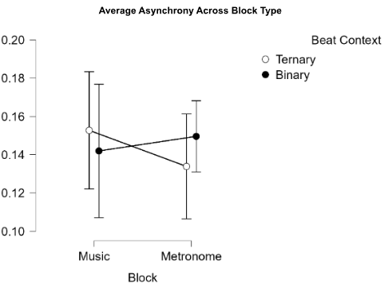
Figure 2. The average asynchronies from the Sustained Beat Task, separated by music and metronome blocks. Trials with binary contexts are shown to be higher during the metronome block, while trials with ternary contexts are shown to be higher during the music block.

3.1.2 Results From Other Beat And Temporal Tasks
For the Tap-to-Music Task, A two-factor within subjects ANOVA revealed a significant effect of tempo (F(1,9) = 5.50, p = .047, η²_{p} = .407) and no significant interaction between beat context and tempo.
Regarding the Synchronization-Continuation Task, a paired samples t-test revealed a significant difference between standardized asynchrony of taps during the synchronization phase (M = .026, SD = .014) compared to the continuation phase (M = .044, SD = .003). For the unstandardized asynchronies, a two-factor within subjects ANOVA revealed a significant effect of tempo (F(1,9) = 19.30, p < .001, η²_{p} = .682), and a significant interaction between tempo and task phase (F(1,9) = 18.14 p < .001, η²_{p} = .668). Post hoc Bonferroni tests revealed that for the 900ms IOI condition, asynchronies increase when going from the synchronization phase (M = .151, SD = .142) to the continuation phase (M = .267, SD = .049), while the asynchronies decrease for the other two tempo conditions (see Figure 3).
At the time of writing this paper, temporal precision from the Tempo Perturbation Task has yet to be calculated.

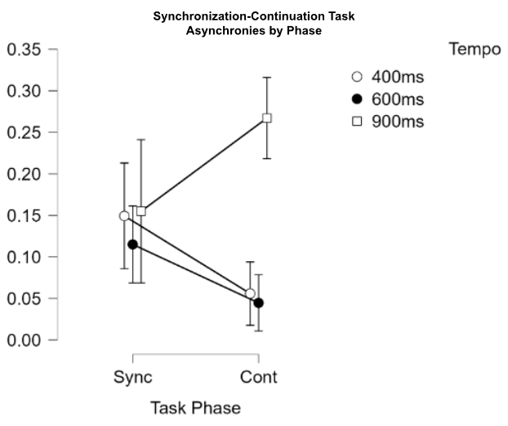
Figure 3. Average Asynchronies across the Synchronization-Continuation Task. Asynchrony increases for trials with 900ms tone IOIs, but decreases for the 400ms and 600ms IOI trials.
3.2 Questionnaire Results
3.2.1 Measures of Empathy
Across all participants, the mean score of empathy from the TEQ was 44.9, SD = 10.07, ranging from 25 to 60. This puts our sample very close to average empathy. For the sub-measures of the IRI, participants had a mean perspective taking score of 19.3, SD = 4.57 with a range of 13 to 27, a mean fantasy score of 19.6, SD = 4.62 with a range of 13 to 26, a mean empathic concern score of 19.7, SD = 5.38 with a range of 11 to 28, and a mean personal distress score of 12.5, SD = 3.81 with a range of 3 to 16. Pearson’s correlation tests revealed a significant correlation between TEQ scores and the IRI sub-measures of empathic concern (r = .943, p < .001), and perspective taking (r = .715, p = .20). A composite empathy score was created by summing up the results from each test (see Figure 4)
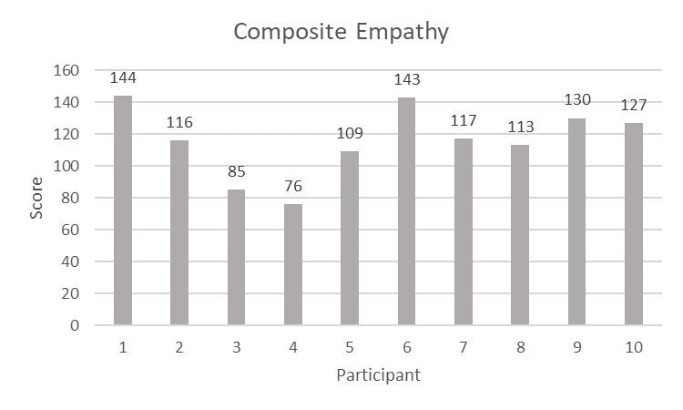
Figure 4. Composite empathy scores created using the sum of IRI sub-measures and TEQ scores.
3.2.2 Measures of Musical Sophistication
General musical sophistication scores from the Gold-MSI had an average of 76.6, SD = 9.03, ranging from 62 to 92 (see Figure 5). Regarding each sub-measure, active engagement saw a mean of 41.4, SD = 5.03 with a range from 35 to 49, perceptual abilities saw a mean of 42.8, SD = 3.19 with a range from 37 to 47, musical training saw a mean of 24.7, SD = 5.83 with a range from 15 to 33, emotional engagement saw a mean of 29.4, SD = 4.37 with a range from 21 to 36, and singing abilities saw a mean of 30.0, SD = 5.09 with a range from 20 to 38. Of the ten participants, four reported having no formal music practice, with the average years of musicianship being 6.0 years, SD = 8.56, ranging from 0 to 26.
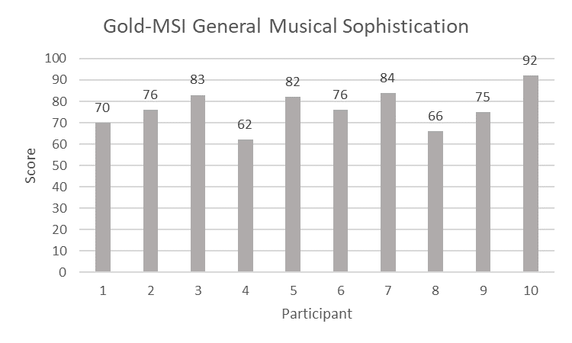
Figure 5. General sophistication scores from the Gold-MSI, a sum of all sub-measures.
3.3 SSEP Results
SSEPs were found at the expected beat beat and stimulus frequencies (see Figures 6A & 6B). A three-factor within subjects ANOVA (beat context * tempo * beat frequency) for mean asynchronies from the music block revealed a significant interaction between beat context, tempo, and beat frequency (F(1,9) = 21.387, p = .001, η²_{p} = .704) though no comparisons passed the post hoc Bonferroni test. There was no main effect of beat context (F(1,9) = .309, p = .592, η²_{p} = .033) or tempo (F(1,9) = 4.09, p = .074, η²_{p} = .312) and no other significant interactions. A three-factor within subjects ANOVA (beat context * tempo * beat frequency) for mean asynchronies from the metronome block revealed no main effect of beat context (F(1,9) = 1.78, p = .216, η²_{p} = .164) or tempo (F(1,9) = 3.80, p = .083, η²_{p} = .297) and no other significant interactions.
A four-factor within subjects ANOVA to compare the same factors as the two prior ANOVAs but with the added factor of task block found a significant effect of tempo F(1,9) = 5.39, p = .045, η²_{p} = .374), but no other significant effect or interaction.
For the SSEPs at the stimulus frequencies, a three-factor within subjects ANOVA (block * beat context * tempo) revealed no significant effect of block (F(1,9) = .201, p = .665, η²_{p} = .022), beat context (F(1,9) = .790, p = .397, η²_{p} = .081), or tempo (F(1,9) = .110, p = .748, η²_{p} = .012). No significant interactions were found.

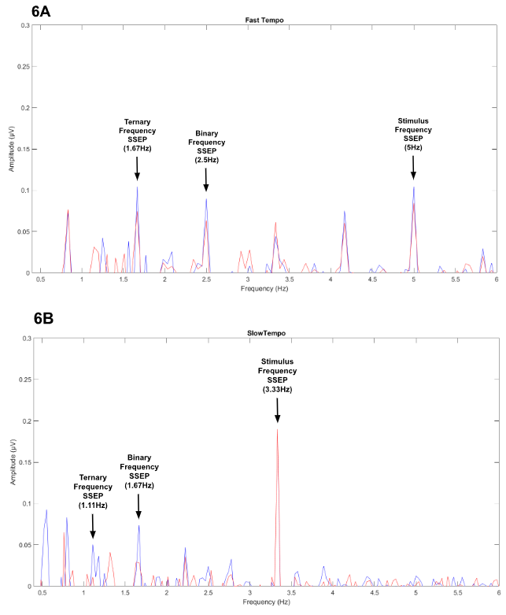
Figure 6. (A) Average SSEP amplitudes across both blocks and both beat contexts for fast trials. (B) Average SSEP amplitudes across both blocks and both beat contexts for slow trials.
3.4 Linear Regression Results
A multiple linear regression analysis was done to predict the beat-level SSEP amplitude based on Sustained Beat Task performance, Tap to Music Task performance, Synchronization-Continuation Task performance (split by synchronization and continuation phases), a composite empathy score, and the Gold-MSI general sophistication score. The regression model was found to be non-significant (F(6,2) = 1.71, p = .414, Adj R²= .347). None of the predictors showed significance. The Durbin-Watson statistic displayed a value of 3.18 suggesting a negative autocorrelation that may indicate a violation of assumptions in this model. Tolerance and Variance Inflation Factor (VIF) statistics showed a possible violation in the assumption of multicollinearity from the measures of Sustained Beat Task asynchrony (Tolerance = .133, VIF = 7.51) and Synchronization-Continuation Task asynchrony from the Synchronization phase (Tolerance = .119, VIF = 8.43). A Pearson’s correlation confirmed that the Sustained Beat Task asynchronies were significantly correlated with both Tap-to-Music Task asynchronies (r = .754, p = .019) and Synchronization-Continuation Task asynchronies for the synchronizing phase (r = .757, p = .011) (see Figure 7). Removing these two measures from the model brought VIF scores below 1.5 for all predictors, suggesting the resolution of the previous collinearity, and the Durbin-Watson statistic fell below three. The model with the two removed predictors was found to be closer to but still not meet the threshold of significance (F(4,5) = 3.92, p = .083, Adj R²= .564). Sustained Beat Task asynchrony was the only significant predictor (t = -3.06, p = .028), while the composite empathy score (t = -.884, p = .417), the Gold-MSI general sophistication score (t = -.006, p = .995), and asynchrony from the continuation phase of the Synchronization-Continuation Task (t = -1.72, p = .146) showed less promise (see Figure 8). When running a simple linear regression to predict the beat-level SSEP amplitude based on Sustained Beat Task performance alone, the model reached significance with 44.5% of variance predicted (F(1,8) = 8.22, p = .021, Adj R²= .445).
When running a multiple linear regression analysis with the same predictors (without Tap-to-Music Task and Synchronization phase asynchrony) to predict SSEP amplitudes at the stimulus frequency, the model failed to reach significance, and had a negative adjusted R² suggesting poor model fit (F(4,5) = .786, p = .580, Adj R²= -.105). In contrast to the beat-level SSEPs, a simple linear regression to predict SSEP aptitudes at the stimulus frequency using just asynchrony from the Sustained Beat Task did not show a significant predictive relationship, and the variance predicted was lower (F(1,9) = 4.286, p = .072, Adj R²= .267).
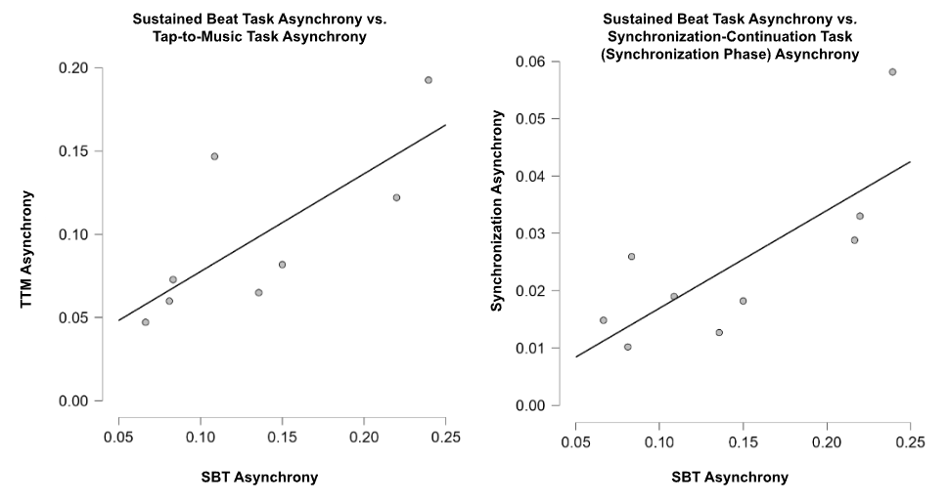
Figure 7. Pearson’s correlations between Sustained Beat Task asynchrony and measures that may show collinearity (Tap-to-Music and Synchronization phase asynchrony). Significant positive relationships exist in both cases.
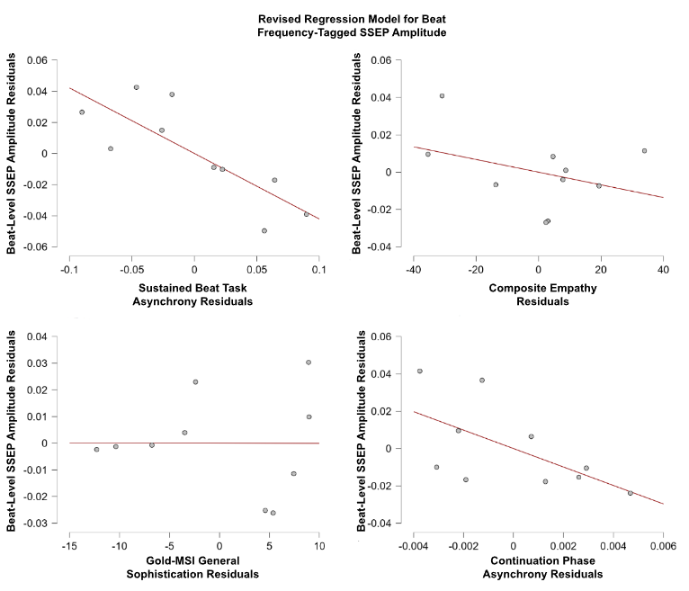
Figure 8. Partial plots for predictors in the revised multiple linear regression model used to predict beat-level SSEP amplitudes. Sustained Beat Task Asynchrony is the only predictor to be significant, and the model overall fails to show significance.
4 Discussion
The current study utilizes a novel paradigm to induce the perception of two different beats and maintain them over an ambiguous period. This allows for the existence of a beat percept initially invoked by natural musical stimuli or metronomic stimuli to exist without exogenous factors. This addresses limitations of other studies that have used frequency tagging to measure neural correlates of beat perception. Our results show mixed results in support of the relation between beat related task behaviour and SSEPs at the beat frequency, with some promise that warrants further investigation into such a relation. General temporal abilities showed inconclusive results, and more exploratory factors such as musical sophistication and trait empathy did not display a relation with beat-level SSEPs.
4.1 Relation Between Behavioural Tasks and SSEPs
Our results suggest an overall complex interaction among predictors in relation to beat-level SSEP amplitude. High degrees of collinearity between all the behavioural tasks suggest an underlying relation between Sustained Beat Task related beat perception, more general beat processing abilities, and general temporal processing abilities. This however makes it difficult to separate the contributions of the underlying factors measured by each of our behavioural tasks within our regression model. Asynchrony from the Sustained Beat Task was the only predictor to show significance within the non-significant model and emerged with significant predictive power for a substantial amount of variance through the simple linear regression. This suggests that under the assumption that no other factors influence the SSEP amplitudes, beat perception may have a strong predictive relationship with SSEP amplitude at beat frequencies. Assumptions like such rarely happen to be the case in real life scenarios, however this predictive relationship warrants further investigation and supports the notion that SSEPs tagged at beat related frequencies are related to beat perception mechanisms. Another simple linear regression did not show such a predictive relation for SSEPs at the stimulus frequency. This comes in contrast with previous literature which showed a relation between task performance and SSEPs at the stimulus frequency but not the beat frequency (Nave et al., 2023).
The remaining measure that did not violate colinearity with the Sustained Beat Task was asynchrony from the continuation phase of the Synchronization-Continuation Task. While the regression analysis showed no significance for this measure as a predictor, it is difficult to make conclusions about the relation between general temporal abilities and beat-level SSEPs when other measures such as asynchrony from the synchronization phase show high collinearity with measures of beat perception. Inclusion of temporal precision scores from the Tempo Perturbation task may shed more light on this relationship. Similarly, the collinearity shown by asynchrony from the Tap-to-Music Task with asynchrony from the Sustained Beat Task makes it hard to draw conclusions about the predictive power of more general measures of beat perception from an indirect task on beat-level SSEPs.
4.2 Relation Between Other Measures and SSEPs
The more exploratory measures of trait empathy and musical sophistication were found to be non-significant predictors with low percentages of variance predicted. This suggests that with the presence of stronger predictors such as behavioural task performance, it is not likely that either musical sophistication or trait empathy contribute to differences in beat-level SSEP amplitude. While no broader conclusions can be drawn, the results suggest that the underlying activity behind beat-level SSEPs are not related to factors that may contribute to auditory-motor integrations proposed by previous literature.
4.3 Null Effect of Beat Context
When comparing the SSEP mean amplitudes, our ANOVAs displayed no significant interaction between beat context and beat frequency. This comes in contrast to previous studies that found such a relation, where SSEPs at the binary frequency would be higher with binary contexts, and SSEPs at the ternary frequency would be higher with ternary contexts (Nave et al., 2022). Notably, even though no significant effects of beat context or frequency were found, the SSEP amplitudes at all beat related frequencies were visibly greater for binary context trials than for ternary context trials. While this paradigm is designed to invoke a beat percept, it is very possible for the beat to either be perceived differently or not maintained as the intended context. For repeated tones of equal salience, previous literature has noted a phenomenon of binary bias, where tones will be perceived as more salient in pairs (Drake, 1993). If the percept is lost throughout the ambiguous period, the lack of external beat markers may result in the generation of an endogenous beat percept that differs from the context stimuli. Our experimenter logs have noted 2 participants that may display such a bias (one with a possible binary bias and the other with a possible ternary bias) based on observations. The next step would be to investigate the asynchronies for each participant by condition to determine if any such tendencies have influenced results. It should also be noted that the task is relatively long, often requiring the participant to focus for over an hour to complete both blocks. Experimenter logs also note that certain participants would experience visible fatigue over time, with one participant even apparently falling asleep for one trial. While the perception of beat in this task is supposed to be effortless, lack of focus from fatigue or any attention shifts could lead to a percept never arising or being lost. Furthermore, the length of one individual trial is a considerable duration, with beat maintenance phases lasting 19.2 seconds in fast trials and 28.8 seconds in slow trials. Another more niche note had one participant who noted hearing both binary and ternary beats as a 3:4 polyrhythm over the ambiguous stimuli in some cases, which we suspect is due to their experience as a seasoned musician. Any of these possible factors could explain the discrepancy with previous literature, and it may be of interest to identify possible cases in which high asynchronies are explained by low asynchronies at the IBI of the other beat context.
4.4 Music versus Metronome Conditions
Our Sustained Beat Task was split into two blocks, where the first block used musical stimuli to invoke beat while the second block used metronomic stimuli. This was done to explore possible differences in perception based on the physical properties of the invoking stimulus. The metronomic stimuli provide a high salience at the beat frequency since the only events presented are at the beat frequency or at a subdivision. This differs from musical stimuli in which the salience of the beat is determined by a multitude of compositional factors, and can vary in salience (Madison, 2006). Many studies that examine temporal abilities often use stimuli that are more metronomic or drum like in nature (eg. Tal et al., 2017, Chemin et al., 2014, Nozaradan et al., 2016), but there has been research in adjacent topics such as Parkinson’s research that have explored the different behavioural results from metronomic stimuli versus music (Wittwer, Webster & Hill, 2013; Leow, Parrott & Grahn, 2014). Our aim was to do the same within perceptual research and uncover any potential behavioural or neurophysiological differences, while also influenced by the idea that music is more externally valid to everyday life.
For both the SSEP and Sustained Beat Task behavioural results, our ANOVAs showed no effect of block type. This suggests that the use of music or metronome to investigate perceptual differences do not affect the behavioural outcomes nor do they present differently electrophysiologically, and that conclusions drawn can be more easily compared with previous research that uses stimuli closer to our metronomic stimuli while also being more externally valid top everyday music listening.
4.4 Limitations
The clearest limitation of the Sustained Beat Task comes from the assumption that beat perception is induced and maintained. Even if asynchronies indicate the presence of the correct percept, it is possible that participants used strategies that do not require the maintenance of the beat percept across the maintenance phase to display correct tapping behaviour. One example would be to make a mental note of the beat context and to recall it at the time of tapping. Doing so would allow for the participant to lose the beat percept, or possibly adopt another from the ambiguous stimuli, all while being able to switch back to the correct beat when tapping. It is possible that differences in strategies could have contributed to variability within our SSEP results.
Limitations also occurred outside of the experimental design. Due to a technical error, the first four participants did not do the full 32 trials in either block of the Sustained Beat Task and instead only did 16 each. This means that for those participants, the average asynchronies and SSEP amplitudes were calculated with fewer trials. In general, our study is relatively underpowered. Many of the insignificant effects that we expected to be significant, or failures to meet assumptions for our linear regressions may be an effect of a small sample size. Continuing this study and gathering a more adequate number of participants could result in more accurate models and relations.
4.5 Broader Implications
The importance of the results of this study mainly lie in the interpretation of past and future literature. Many studies use beat frequency-tagged SSEPs as measures of beat perception either explicitly or in an implied fashion. While perceptual research may seem to have main implications that are less application based, clinical or diagnostic implications are possible. The way that frequency-tagged SSEPs are used in the literature should be verified to be valid, to avoid situations in which an electrophysiological measurement does not measure the activity that it is intended to, because it is not known if that activity will be found to correlate with clinical or diagnostic measures in the future.
4.6 Conclusion
In summary, our results show promise in validating the relation between beat related behaviour and corresponding frequency-tagged SSEPs. Other proposed predicting factors either showed inconclusive or invalidating results, but due to aforementioned limitations, reliable conclusions may be hard to draw. As this study continues after this paper, a clearer picture should be painted with the addition of a greater sample.
5 Acknowledgements
With the deepest appreciation, I would like to thank Dr. Karli Nave for her guidance as my supervisor in the past two years, my principal investigator Dr. Jessica Grahn for welcoming me into her lab, and my research partner on this study Eryn Lonnee for all her contributions and the initial conception of this study.
References
Abecasis, D., Brochard, R., Granot, R., & Drake, C. (2005). Differential brain response to metrical accents in isochronous auditory sequences. Music Perception, 22(3), 549-562.
Bamford, J. M. S., & Davidson, J. W. (2019). Trait Empathy associated with Agreeableness and rhythmic entrainment in a spontaneous movement to music task: Preliminary exploratory investigations. Musicae Scientiae, 23(1), 5-24.
Chemin, B., Mouraux, A., & Nozaradan, S. (2014). Body movement selectively shapes the neural representation of musical rhythms. Psychological Science, 25(12), 2147-2159.
Davis, M. H. (1980). Interpersonal reactivity index.
Drake, C. (1993). Reproduction of musical rhythms by children, adult musicians, and adult nonmusicians. Perception & Psychophysics, 53, 25-33.
Drake, C., Penel, A., & Bigand, E. (2000). Tapping in time with mechanically and expressively performed music. Music Perception, 18(1), 1-23.
Hannon, E. E., Snyder, J. S., Eerola, T., & Krumhansl, C. L. (2004). The role of melodic and temporal cues in perceiving musical meter. Journal of Experimental Psychology: Human Perception and Performance, 30(5), 956.
Iversen, J. R., & Patel, A. D. (2008, August). The Beat Alignment Test (BAT): Surveying beat processing abilities in the general population. In Proceedings of the 10th international conference on music perception and cognition (pp. 465-468). Sapporo, Japan Adelaide: Causal Productions.
Jackendoff, R., & Lerdahl, F. (2006). The capacity for music: What is it, and what’s special about it?. Cognition, 100(1), 33-72.
Large, E. W., & Kolen, J. F. (1994). Resonance and the perception of musical meter. Connection science, 6(2-3), 177-208.
Leow, L. A., Parrott, T., & Grahn, J. A. (2014). Individual differences in beat perception affect gait responses to low-and high-groove music. Frontiers in human neuroscience, 8, 811.
Longuet-Higgins, H. C., & Lee, C. S. (1984). The rhythmic interpretation of monophonic music. Music Perception, 1(4), 424-441.
Madison, G. (2006). Experiencing groove induced by music: consistency and phenomenology. Music perception, 24(2), 201-208.
McPherson, T., Berger, D., Alagapan, S., & Fröhlich, F. (2018). Intrinsic rhythmicity predicts synchronization-continuation entrainment performance. Scientific reports, 8(1), 11782.
Müllensiefen, D., Gingras, B., Musil, J., & Stewart, L. (2014). The musicality of non-musicians: An index for assessing musical sophistication in the general population. PloS one, 9(2), e89642.
Nave, K. M., Hannon, E. E., & Snyder, J. S. (2022). Steady state‐evoked potentials of subjective beat perception in musical rhythms. Psychophysiology, 59(2), e13963.
Nave, K. M., Hannon, E. E., & Snyder, J. S. (2023). Replication and Extension of Nozaradan, Peretz, Missal and Mouraux (2011). Manuscript submitted for publication.
Nozaradan, S., Peretz, I., & Keller, P. E. (2016). Individual differences in rhythmic cortical entrainment correlate with predictive behavior in sensorimotor synchronization. Scientific reports, 6(1), 20612.
Nozaradan, S., Peretz, I., Missal, M., & Mouraux, A. (2011). Tagging the neuronal entrainment to beat and meter. Journal of Neuroscience, 31(28), 10234-10240.
Pecenka, N., Engel, A., & Keller, P. E. (2013). Neural correlates of auditory temporal predictions during sensorimotor synchronization. Frontiers in human neuroscience, 7, 380.
Pecenka, N., & Keller, P. E. (2009). Auditory pitch imagery and its relationship to musical synchronization. Annals of the New York Academy of Sciences, 1169(1), 282-286.
Povel, D. J., & Essens, P. (1985). Perception of temporal patterns. Music perception, 2(4), 411-440.
Repp, B. H., & Steinman, S. R. (2010). Simultaneous event-based and emergent timing: synchronization, continuation, and phase correction. Journal of Motor Behavior, 42(2), 111-126.
Ravenscroft, I. (1998). What is it like to be someone else? Simulation and empathy. Ratio, 11(2), 170-185.
Spreng*, R. N., McKinnon*, M. C., Mar, R. A., & Levine, B. (2009). The Toronto Empathy Questionnaire: Scale development and initial validation of a factor-analytic solution to multiple empathy measures. Journal of personality assessment, 91(1), 62-71.
Styns, F., van Noorden, L., Moelants, D., & Leman, M. (2007). Walking on music. Human movement science, 26(5), 769-785.
Tal, I., Large, E. W., Rabinovitch, E., Wei, Y., Schroeder, C. E., Poeppel, D., & Golumbic, E. Z. (2017). Neural entrainment to the beat: The “missing-pulse” phenomenon. Journal of Neuroscience, 37(26), 6331-6341.
Thompson, E. C., White-Schwoch, T., Tierney, A., & Kraus, N. (2015). Beat synchronization across the lifespan: Intersection of development and musical experience. PloS one, 10(6), e0128839.
Wittwer, J. E., Webster, K. E., & Hill, K. (2013). Music and metronome cues produce different effects on gait spatiotemporal measures but not gait variability in healthy older adults. Gait & posture, 37(2), 219-222.

